IT Committee Meeting
March 3, 2015, 11:00 am

In attendance: Chuck Lane, Victor Bissonnette, Matt Hinson, Curt Hersey, Cam Jordan, Christine Anton, Tom Hocut, Callie Starnes, Jessica, Sherre Harrington, Jennifer Palamuso, Penny Evans-Plants

Next meeting 4/7 at 11 - last meeting of semester unless we need to meet in May.

Chair of committee for 2015-16: Dr. Hersey is happy to serve.

VoIP/Office 365 update (Penny and Tom) - two processes but will be migrated at same time. We have a FAQ document to help faculty and staff with mobile devices since users will need to delete and recreate accounts.
Working on final plan but initially plan to migrate all faculty and surrounding staff before summer and migrate remaining staff during summer.
Communication to campus will be out by end of the week
One Drive - limited to 20,000 files
Can replace DropBox and Google Drives
Question - does that increase the size of emails we can send? Tom - we have set it to 30MB which is the same as it is now.
You will need to import the .pst files if you want your archived emails back in your mailbox.

Password Change Policy - Dr. Lane asked to discuss the proposed new password policy of changing it every 90 days and increasing the number of password characters to 8 minimum. He expressed concern that the new policy would have unintended consequences with employees writing down passwords and leaving them visible or easily accessible.
Tom: from a security standpoint, the number one way hackers get in is via a hacked password. The reason we do it is to reduce risk to our environment.

Following are additional comments/questions:
There are a lot of large corps who don't require users to change pw every 90 days. Could we implement a process like Steam, etc. where if you login from a new device it asks for more info than from usual machines? Tom agreed to look into that to see if feasible.
Presented in light of cyber security insurance issue and the audit - can we empower users with tools to make the process easier?
Would insurance pay out if user wrote it down and it was stolen, resulting in a data breach? Penny will need to find out answer from Garner and Glover.
Dr. Anton mentioned that VikingWeb passwords have never changed and someone else mentioned that JobX/TimeSheetX passwords haven’t either. OIT will need to make sure those systems (and possibly others) are included in the password change policy.

Conclusion: Group agreed it is necessary for OIT to move forward with the password change plan. Complexity of the pw is what's important so OIT needs to include recommendations on how to generate secure passwords and how to store them safely. Make communication as user friendly as possible. Clearly explain the algorithm and complexity rules so the community can more easily set them up.

Kaltura – Dr. Bissonnette asked when will faculty who are teaching online/blended summer courses have access to the new Kaltura system? Penny responded that training is scheduled to begin this week and we should be complete within the month.

Blended Course Definition
Dr. Bressette asked the group to provide feedback regarding the Rollins definitions for blended/online courses. There is an ad hoc committee working on this but they would like input from the IT Committee. Chuck thinks the Traditional courses should be 0-2%. Victor - downplay the percentage numbers and emphasize the online activity definition. Outside activity that substitutes for class is the distinction that Rollins make.

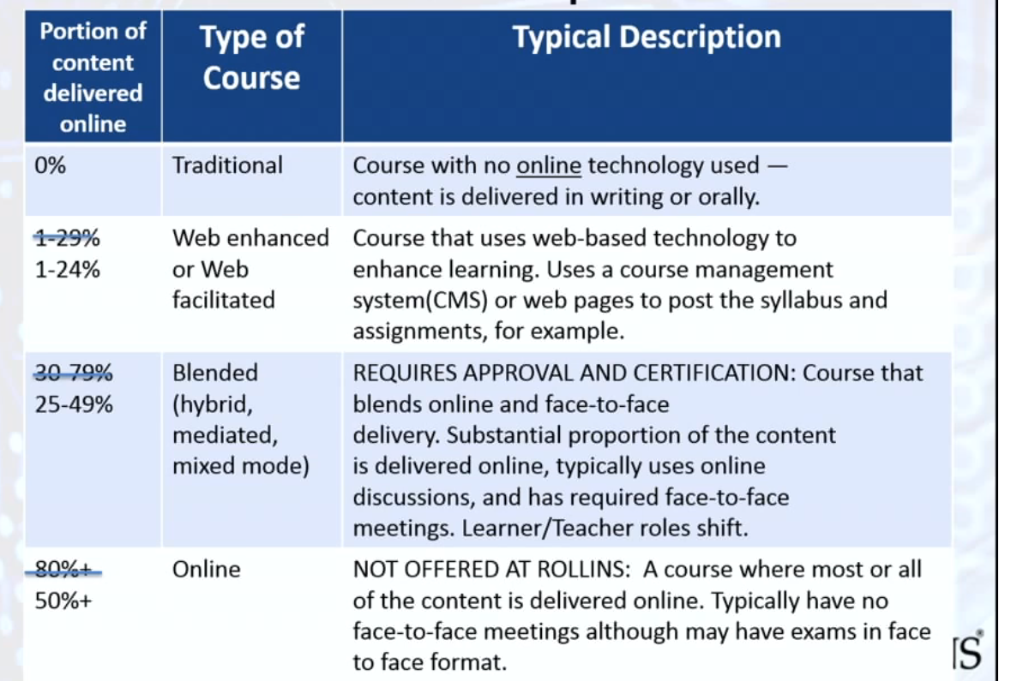

It was suggested that the members send input directly to Andy.

Meeting adjourned at 11:57.

Respectfully submitted,

Penny Evans-Plants
CIO

